North for Science! 2023
Trip Report

North for Science! 2023 was remarkable success with a diverse group of Fairbanks area middle-school students learning and camping together for eight days June 7 – 14, 2023 along the Dalton Highway.

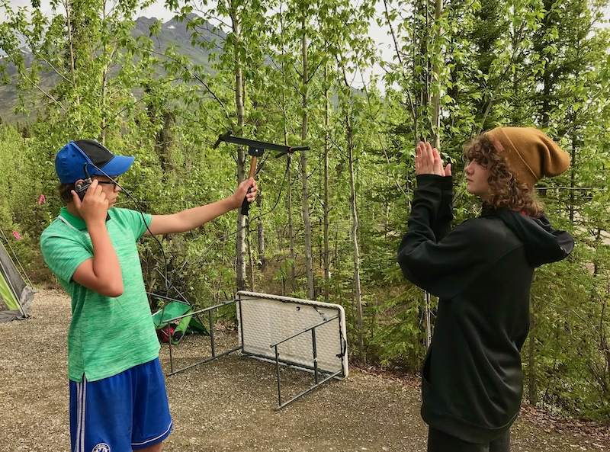
While at Marion Creek campground on the south slopes of the Brooks Range, we participated in bear awareness training with a BLM professional and Leave No Trace training with an NPS intern, hiked to Marion Creek Falls, located radio collars using telemetry equipment under the tutelage of a FWS biologist, conducted hare pellet counts for an NPS biologist, and gathered data on a boreal forest transect. On our way further north, we visited the community of Wiseman to gain insight into the local mining history and a different perspective of living in the Brooks Range.

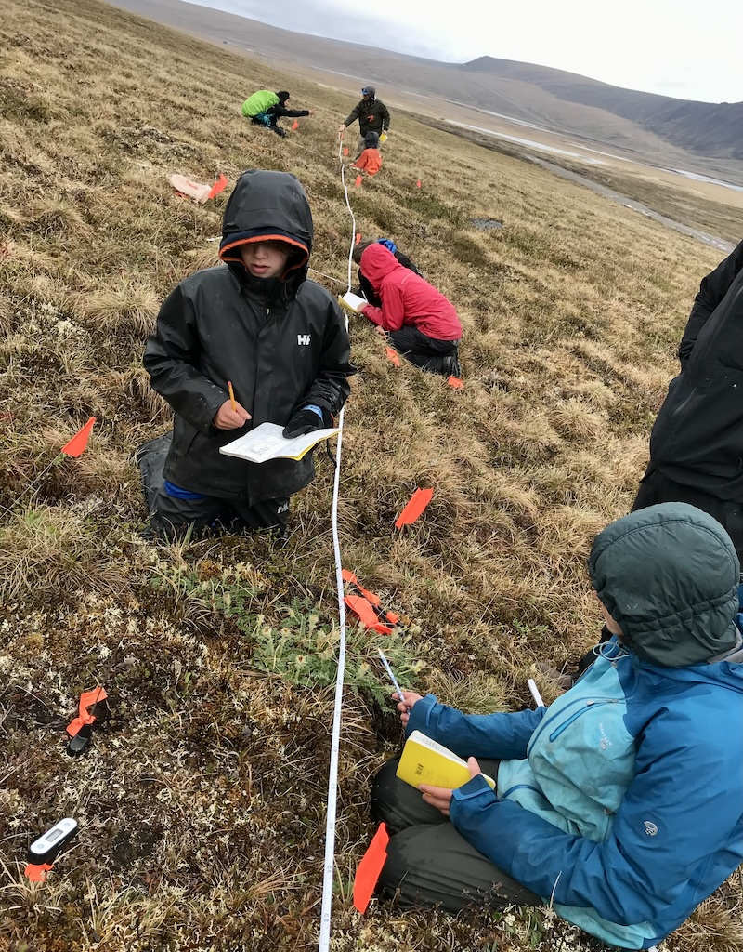
While camped at Galbraith Lake on the north slopes of the Brooks Range, we visited UAF’s Toolik Field Station to learn from staff and researchers there. We spent our last field day gathering data on a tundra transect and playing on a field of aufeis.

Throughout this fun-and-learning filled week team members were engaged, enthusiastically soaking up every new experience. Despite the rapidly changing – and often wet – weather, they enjoyed living outdoors with a new group of friends, all in awesome surroundings.

To describe the experience, one participant wrote:

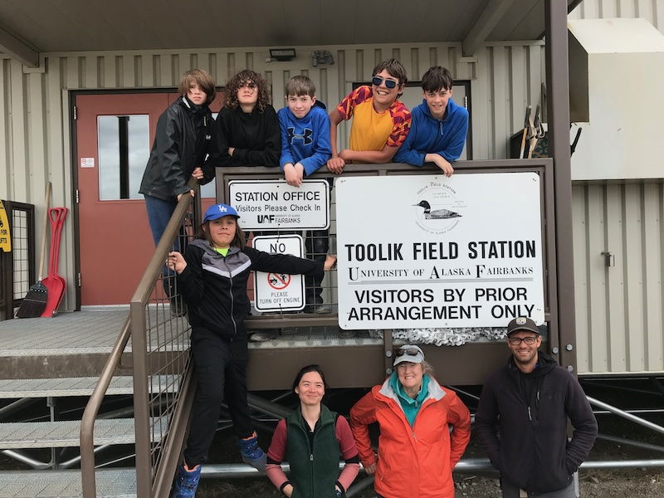
“If I was telling people about North for Science I would tell them what a great program it is. I would tell them all of the amazing opportunities there are and the friendships that you could build… it is honestly just an incredible experience and a great place to build teamwork skills. I would tell them about all of the adventures they will go on like hiking to a waterfall or helping real scientists with their studies. I would tell them about seeing beautiful landscapes … I would tell them about getting to go to a real science lab. I would tell them how great it is to spend a week in the wild away from the hustle and bustle of everyday life and how great it is to wake up knowing that all you are going to do is learn and have fun.”

