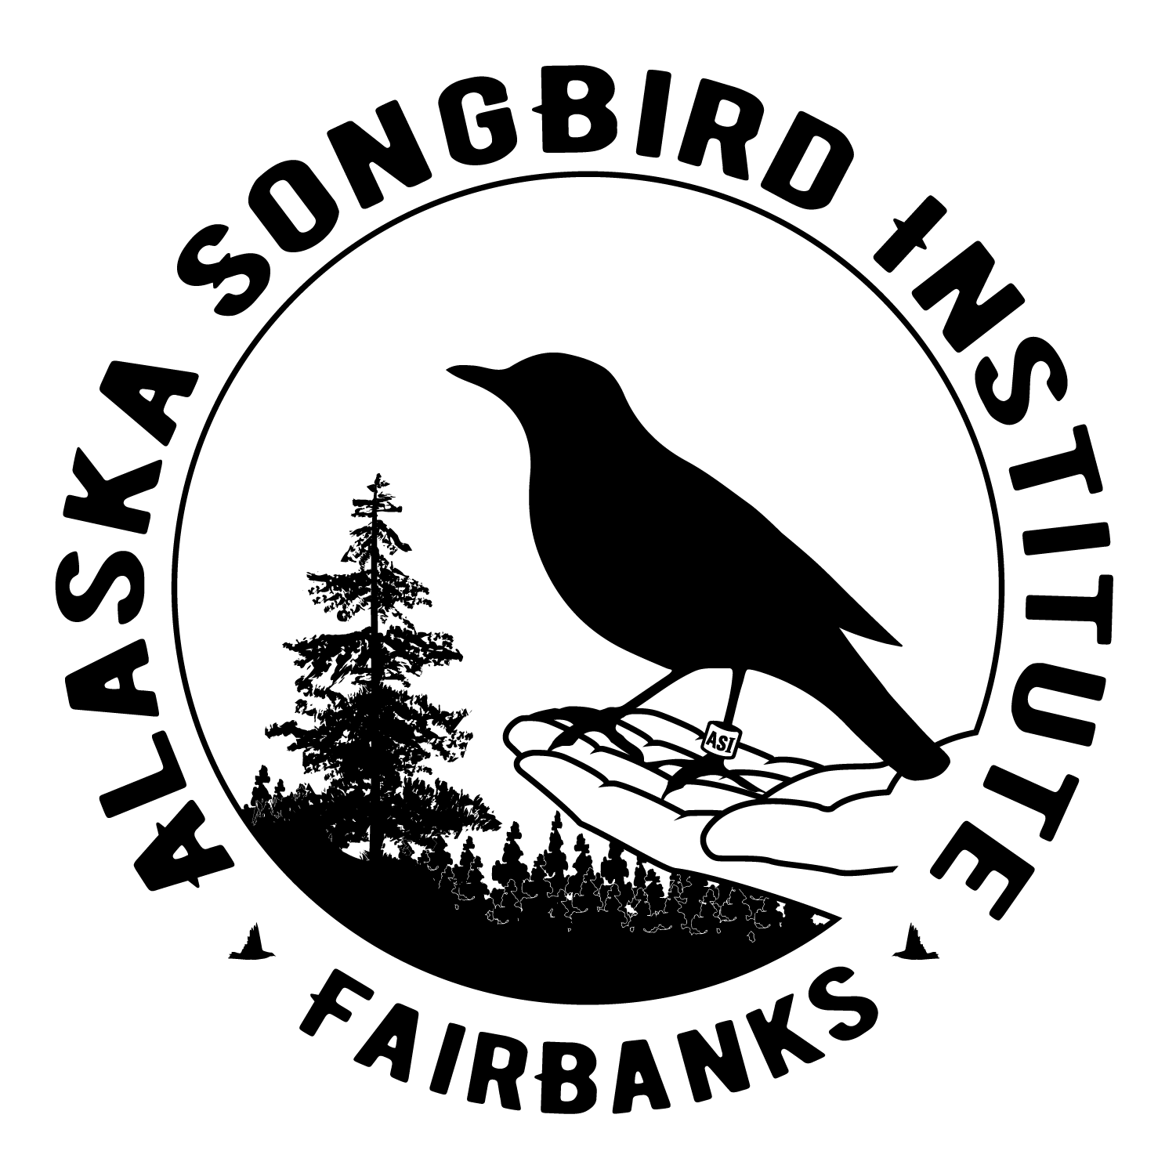
ASI Virtual Field Trip Extension Ideas

Educators and parents can find ASI’s new virtual field trip to Creamer’s Field and our bird banding station at: https://aksongbird.org/virtual-field-trip/. You can use this direct link for your students: https://arcg.is/CPCaC

It should take students about 20 minutes to complete the virtual field trip. It contains the same basic content as our traditional in-person field trips including: bird taxonomy and adaptations, the boreal forest ecosystem and its connection to birds, the basics of scientific research, migration, Alaska bird conservation, and the historic conservation story of Creamer’s Field. These broad topics provide many jumping off points to grade level curriculum!

Here are some ideas to get started:

- Students can choose one of the conservation actions from ASI’s Backyard Bird Hero video to implement at home. Describe this in written or video format, and share with the class.

- Ask students to choose one of the species shown in #7: Meet the Birds! Learn more about this species by visiting the Cornell Lab of Ornithology’s All About Birds online bird guide: www.allaboutbirds.org and search for this species around their home. Teach the class by sharing their experience and new information about their species in written, audio, or video format.

- Submit questions to Ask a Bander! at: programs@aksongbird.org individually, or as a class.

- Explore Yaqulget Ayuqenrilnguut: Birds in Abundance, found at: www.yupikscience.org.

- Watch one or more of the additional ASI bird and birdwatching videos found at: https://aksongbird.org/education/birdwatching-videos/. Each is followed by links for learning more.

- Students can dive into bird physiology with Cornell’s Bird Anatomy Lab: https://academy.allaboutbirds.org/features/birdanatomy/

- Older students can delve deeper into migration science and uses of bird banding data:
- U.S. Bird Banding Lab
https://www.usgs.gov/centers/pwrc/science/why-do-we-band-birds?
- Bird Banding & Mist Netting with Point Blue Conservation Science
https://youtu.be/8nVXgGhQNXM
- Point Blue’s Palomarin Field Station Data Explorer
https://www.pointblue.org/our-work/keystone-datasets/palomarin-field-station-data-explorer/
- ASI’s Bird Banding Blog
https://creamersfieldbanding.blogspot.com/

- Creamer’s Field Virtual Field Trip Scavenger Hunt. Two copies are provided (one with answers!) Feel free to add, delete, or adjust as needed!
ASI Virtual Field Trip Scavenger Hunt

(Teacher’s Version with answers!)

- What is one thing planted in the fields at Creamer’s Field?
Any one of the following: barley, barley sprouts, field peas, agricultural crops

- How many sandhill cranes live in the middle Tanana River valley (where Fairbanks is located?)
30,000

- Describe one way to tell the difference between an adult and colt (young) sandhill crane?
Any of the following:
Adult: red skin patch on its head, orange eye, black bill, feathers are mostly gray.
Young of the year (colt): feathered head, dark eye, peach bill, and its feathers are russet or orange.

- Name one kind of habitat found in the boreal forest?
forests, lakes, river valleys, wetlands, peatlands, tundra

- Why is the boreal forest called North America’s bird nursery?
It is the birthplace of billions of birds each year. Over 300 species nest here.

- Why are is the boreal forest important in protecting against climate change?
They store more carbon then any ecosystem on earth!

- What are two things that a songbird’s syrinx allow it to do that other animals can not do?
It allows them to sing two notes at the same time and sing while they are breathing in and out.

- Name at least one reason that birds vocalize.
Any of the following: Chicks call to their parents when hungry. They call out warnings to each other. They call to check in with others in their flock or their mate. And songbirds sing! Songs that help them defend a territory and distinguish them from other species.

- What is a tool that helps scientists tell birds of the same species apart?
Bird band

- What is the world’s largest songbird?
Raven

- Describe one way that you can be a bird conservation hero.
Answers will vary but may include: feeding birds, protecting them from window collisions, planting native plants, building nest boxes, providing bird baths or other water, keeping cats on leashes or indoors, learning more about birds, teaching others about birds.

ASI Virtual Field Trip Scavenger Hunt

- What is one thing planted in the fields at Creamer’s Field?

- How many sandhill cranes live in the middle Tanana River valley (where Fairbanks is located)?

- Describe one way to tell the difference between an adult and colt (young) sandhill crane.

- Name one kind of habitat found in the boreal forest?

- Why is the boreal forest called North America’s bird nursery?

- Why is the boreal forest important in protecting against climate change?

- What are two things that a songbird’s syrinx allow it to do that other animals can not do?

- Name at least one reason that birds vocalize.

- What is a tool that helps scientists tell birds of the same species apart?

- What is the world’s largest songbird?

- Describe one way that you can be a bird conservation hero.

