Program Partners:
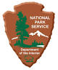
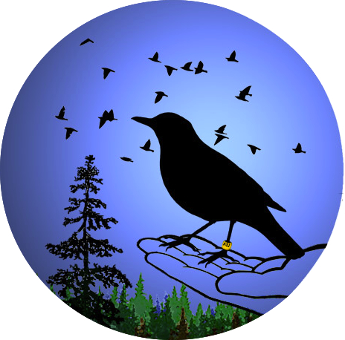
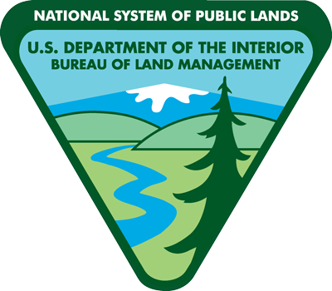
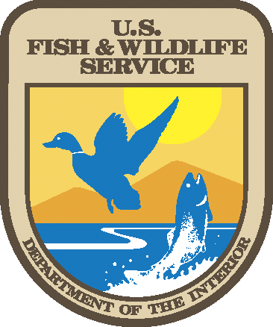
Alaska
Songbird
Institute

North for Science! Expedition
Teacher/Adult Mentor Recommendation

Thank you for providing this recommendation for a student who is applying to be a North for Science! Expedition 2017 Team Member. During the North for Science! Expedition students will travel the Dalton Highway and camp in the central Brooks Range. They will investigate the uniqueness of the subarctic and arctic ecosystems alongside scientists and education specialists. This program is funded cooperatively through many partners and sponsors at no cost to the student.

The North for Science! Expedition is an active science education learning experience requiring all participants to be energetic, flexible team members. Students need to enthusiastically engage in all opportunities the expedition presents, from staying focused during educational activities to assisting with camp chores. Given our close living and working situation, team members must already possess good social skills and be able to interact well with a diverse group of peers and adults.

We appreciate your time in helping us find a diverse group of science-minded middle school students who will benefit from this opportunity. Unfortunately, we are unable to accept all students who apply to North for Science!, so any information that helps this student stand out will be helpful. All information will remain confidential. Please provide responses to the following questions regarding the student applicant.

Please type directly onto this form and email it. You can also type or write your responses on a separate sheet then scan and send them. If you cannot scan, you can take a good quality picture with your mobile device and send the photo. Send all completed responses to:

carol.scott@aksongbird.org Deadline: Wednesday, April 26th, 2017.

Your Name:
Your Email:
Name of Student Applicant:

- How long have you known this student, and in what capacity?

- Please describe this student’s ability to participate as a member of a team.

- Please describe this student’s ability to communicate with adults and peers.

- Please describe anything else about this student you would like us to know in regards to their application to this program.

Thank you for supporting this student!

