Program Partners:
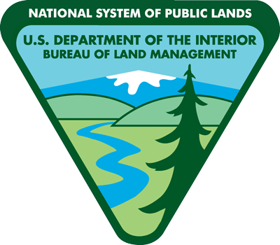
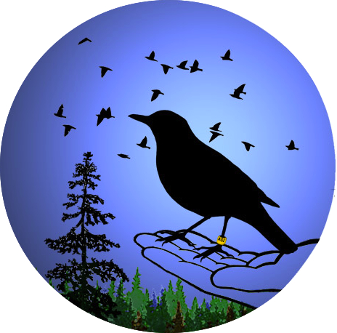
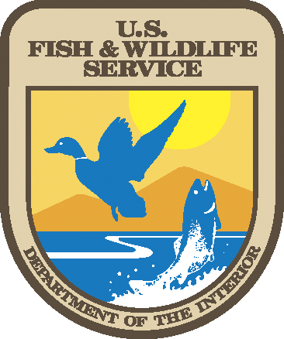
Alaska
Songbird
Institute

North for Science! Expedition
for current 7th and 8th grade students

Program Overview:

The North for Science! Expedition is an active science education learning experience that requires all participants to be energetic, flexible team members who can be depended upon to enthusiastically engage in all opportunities the expedition presents, from staying focused during educational activities to assisting with camp chores. We will be working hard together, living outdoors and getting dirty… most likely in a range of weather conditions: warm to cold, wet to dry, clear to buggy! Although this is not a backpacking or extended hiking trip, all team members need to be comfortable carrying a daypack for long periods, and walking over uneven, sloping terrain. At all times students should be equipped for sudden changes in the weather. Safety is of paramount concern in all aspects of the expedition, and students are expected to immediately comply with the direction of the instructors.

Students who are selected to participate in the North for Science! Expedition are expected to fully engage in all daily activities and discussions, and assist with the smooth operation of the program at all times, although there will be times for individual daily reflection. We also plan to document our learning activities with photo and video, and students are expected to assist in presenting their North for Science! experience in a community forum in the fall of 2017. This is a “team educational program” as opposed to being a “summer camp.” The team will drive from Fairbanks north on the Elliot and Dalton Highways to the Coldfoot area on the southern slopes of the Brooks Range. We will first camp in the Marion Creek Campground, our base for investigating the subarctic ecosystem with various researchers and agency specialists. We then continue north over Atigun Pass, and establish camp at Galbraith Lake. Here we investigate the arctic ecosystem, and visit with researchers at Toolik Field Station before driving south back to Fairbanks.

Anticipated expedition dates: June 7-14, 2017
Orientation meeting: 6:30 – 8:00 p.m. Monday June 5, 2017
Personal gear check by appointment prior to orientation. We provide most camping gear, and have some personal gear to loan out if you have not camped before.

A. North for Science! Student Application:

If you are interested in being a part of this expedition, please provide answers to the following questions. A one-paragraph response to questions 1-6 should be sufficient.

Please type directly onto this form and email it. You can also type or write your responses on a separate sheet then scan and send them. If you cannot scan, you can take a good quality picture with your mobile device and send the photo. Please make sure your handwriting is easily legible. Send all completed responses to:

carol.scott@aksongbird.org

Your Name:
Your age in June 2017:
Your current grade:
Your current school:

Your home address:
Best email address for contact:

- What do you hope to gain from being a member of the North for Science! Expedition?

- Tell us about a time you were able to work well in a group.

- Tell us about a time you found it challenging to work well in a group, and what did you do to meet this challenge?

- Describe a situation you have been in that proves you are responsible, dependable, and can communicate well.

- What interests you most about science?

- Describe any camping and sports-type experience you have (NOTE: prior camping experience is not a requirement for this program, nor do you need to be a serious athlete. Being a physically active person is required).

- Ask one of your current teachers or an adult who knows you in a work or group-type setting (and who is not a family member) if they will provide a brief reference for you to attend North for Science! Ask this person to find the teacher/adult mentor recommendation link on Alaska Songbird Institute’s webpage: http://aksongbird.org/north-for-science/

Please provide us the name and email address of this person, so we can follow up with them if necessary.
Teacher/adult mentor name and school or relationship to you:
Teacher/adult mentor email address:

B. Parent/Guardian Section:

Parents/Guardians, please read the Program Overview of the North for Science! Expedition located at the beginning of this application. Although we are traveling on and camping near a road, the central Brooks Range is remote. Safety is our constant first priority, but please understand there are no medical facilities north of Fairbanks. If your student has a known medical condition that may require immediate attention when triggered (for example, severe allergic reaction to bee stings), this may not be the best program for them. Please contact Carol Scott with questions: carol.scott@aksongbird.org

Please indicate by writing your name and email below that you have read the North for Science! Program Overview, can attend the pre-trip and gear check meetings, and understand both the opportunities that await your student and the remote nature of the Dalton Highway.

Parent/Guardian name(s):

Parent/Guardian email:

Thank you!

Send this complete application to:
Carol Scott carol.scott@aksongbird.org
Application Deadline: Wednesday April 26th, 2017.

